# To install Drupal with Terminus on Windows 7

## Install Programs

### GitBash

1. Go to the site: <http://git-scm.com/downloads> and download the installer.
2. Install the program using all default settings and directories.

### Drush

1. Go to the site: <https://github.com/drush-ops/drush> and go to the “Install Drush On Windows” section to download the installer
2. In the install process, use the default directory
3. Under the “Custom Setup” screen, choose to install the entire feature.

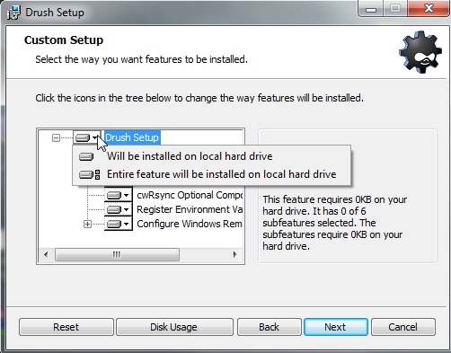

1. If you have previously installed Drush, simply reopen the install file and click ‘Change’ to change the features that have been installed.

### WAMP

1. Go to the site: <http://www.wampserver.com/en/>
2. Choose the “Wamp Server (32 Bits..)” and click the ‘download directly’ link that is almost hidden in the first paragraph.
3. Install using the default settings.
4. Start Wamp Server service by opening the program. A green ‘W’ will appear in the right end of your task bar near the clock. If the icon is not green you will need to troubleshoot the problem.
5. Enable Wamp Modules
   1. Click on the Wamp icon
   2. Expand ‘Apache’ and ‘Apache Modules’ and make sure ‘rewrite_module’ is checked

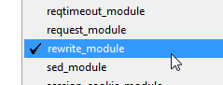

* 1. Expand ‘PHP’ and ‘PHP Extensions’ and make sure ‘php_curl’ is checked

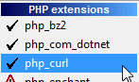

1. Enable vhosts
   1. Click on the Wamp icon
   2. Expand ‘Apache’ and click on ‘httpd.conf’

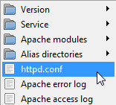

* 1. Search for the line that includes ‘httpd-vhosts.conf’
  2. Remove the # at the beginning. The line should look similar to this:

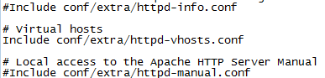

1. Click on the Wamp icon and click ‘restart all services’

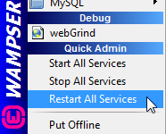

1. Click on the Wamp icon and click ‘Put Online’.

### Composer

1. Go to the site: <https://getcomposer.org/download/> and download the windows installer
2. During the install process, choose the php.exe file that exists in your wamp directory. Typically this should be similar to ‘C:\wamp\bin\php\php5.5.12’

## Environment Setup

### Setup Git

1. Open Git Bash program
2. Enter the following commands with a name and email for yourself
   1. Git config –global user.name “John Doe”
   2. Git config –global user.email [johndoe@email.com](mailto:johndoe@email.com)
3. Close Git Bash for now

### Install Curl Cert

1. Go to the site: <http://curl.haxx.se/ca/cacert.pem>.
2. Right click and ‘save page as’. Save this file in your user’s folder. It should be saved as a .pem file, not a .txt file (this is important).
3. Open up the php.ini file within wamp (typically at ‘C:\wamp\bin\php\php5.5.12\php.ini’)
4. At the bottom of this file add the last line as you see in the screen shot. Adjusting the path as needed.

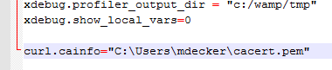

1. Click on the Wamp icon and click ‘restart all services’

## Set Environment Variables

1. Click on the start menu
2. Right click on ‘Computer’ and select ‘Properties’
3. Click ‘Advanced System Settings’ in the upper left, open ‘Environment Variables’
4. In the lower half, find the variable ‘PATH’, click on it and click edit. 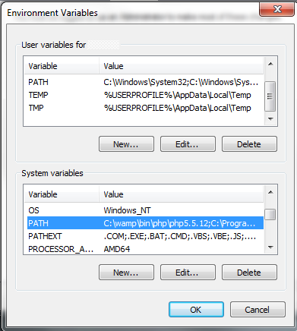
5. Replace the reference to Drush/php with the path to the wamp php.
   * 1. Remove ‘C:\Program Files (x86)\Drush\Php’
     2. Add ‘C:\wamp\bin\php\php5.5.12’ (or similar)
6. Save settings

## Install Terminus

1. Click on the Start Menu and open ‘Git Bash’. (if a Git Bash was open prior to the above steps, close the Git Bash and reopen)
2. Type ‘drush status’, if you get any errors you will need to troubleshoot.
3. Type ‘which php’, if you get any errors or a path that does not lead to the wamp files, you will need to troubleshoot.
4. If the above commands return something like below, continue on.

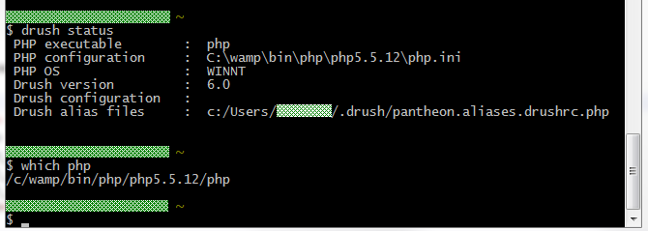

1. Follow the commands below
   1. ‘cd ~’
   2. composer install
      1. If that fails with a message about a composer.json file, create this file in your user folder and add this to the file



* 1. Git clone <https://github.com/pantheon-systems/terminus.git> $HOME/.drush/terminus
  2. cd $HOME/.drush/terminus
  3. composer update –no-dev
  4. drush cc drush

1. If all these commands work, type ‘drush pauth’
   1. It will ask you for your user name and password for pantheon.
   2. If you get a similar screen below, you are set up with terminus.

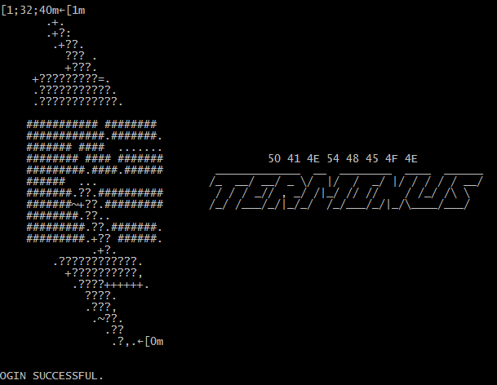

## Install Drupal

### Database

1. Click on the Wamp Icon and click on ‘phpMyAdmin’
2. Click on ‘databases’ and create a database for the desire site.

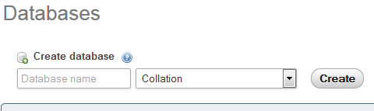

1. Import a site if one already exists, or leave empty

### Files

1. Pull code from pantheon, or from drupal.org.
2. Place the files into the c:/wamp/www directory.
3. Delete the settings.php file in ‘sites/default’ folder of the site.

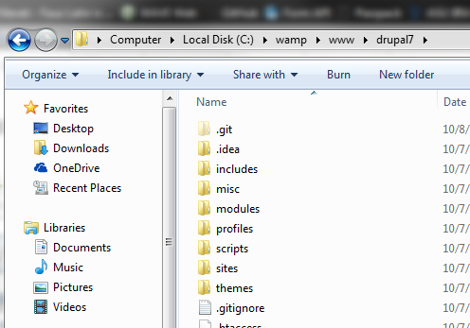

### Vhosts

1. Navigate to ‘C:\Windows\System32\drivers\etc’ and open ‘hosts’ file in a text editor.
2. Add additional lines for each site in the format ‘127.0.0.1 mysite’ or 127.0.0.1 mysite.com’

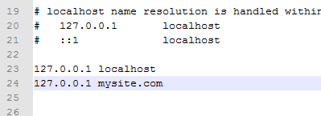

1. Save and close the file
2. Navigate to ‘C:\wamp\bin\apache\apache2.4.9\conf\extra’ or similar, and open the ‘httpd-vhosts.conf’ in a text editor.
3. Add a new Virtual host for each site

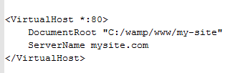

1. Click on the wamp icon, and click restart all services. This is needed anytime the vhosts.conf file is changed.
2. In a browser of your choice, navigate to the path you configured in the ‘hosts’ file.
   1. This should bring you to the drupal install screen. Follow the steps and choose the database you created earlier. Unless you configured the database settings any further, the database username is ‘root’ and the password is left blank.